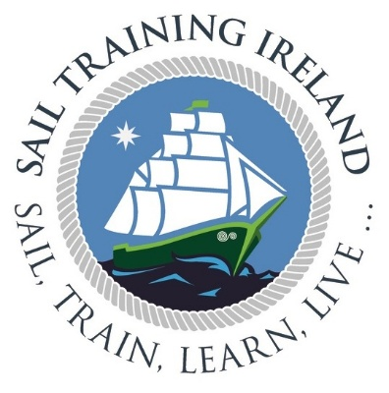
2026 Young Explorer/Gaisce Easter Voyages for 14 - 17-year-olds

You will be boarding/disembarking as follows:

- Monday 20th April 2026 10.00hrs, Join “Maybe” in Belfast Marina (https://maps.app.goo.gl/iNfhrSLHq8puAtbp6)
- Please Note: Please wait at the quayside gate and a member of the crew will collect you and escort you to the vessel when she is ready to board. If there is no one at the gate, or if you are delayed, please use the emergency number below to contact the ship.
- Friday 24th April 2026 17:00 hrs, disembark “Maybe” in Dublin at North Wall Quay, in front of the 3 Arena (https://maps.app.goo.gl/MVWX6sB4gLWSnZ5DA)

All the information you need for your voyage can be found on our website, https://www.sailtrainingireland.com/downloads/

Parents will be able to follow the voyage on Marine Traffic and Vessel Finder websites. On the relevant apps you can find us by searching 'Maybe' and selecting the GBR registered pleasure craft.

Should you need to contact the ship in case of an emergency only please call +44 779 516 4605 (Please only use this number in case of emergency, or if you need to alter your arrival/departure time).
If you need to contact Sail Training Ireland outside office hours in case of an emergency only, please call 085 251 0384.
Neither of these numbers accept WhatsApp or SMS messages, voice calls only.

To contact Sail Training Ireland in non-emergency cases, please email info@sailtrainingireland.com or ring 01-845 4773 during office hours.

The health and safety of our trainees and crew is paramount. All our voyages are weather dependent. We may be forced to cancel a voyage in the event of forecast weather conditions that may impact on the safety and comfort of that voyage. In the case where we must cancel such a voyage due to adverse weather or other unforeseen circumstances, all efforts will be made to provide an alternative voyage / vessel and if that cannot be achieved a full refund will be made.

We look forward to welcoming you on board.
Kind regards,
The Sail Training Ireland Team.

